# Student List and Enrollement System Document

## 1. Introduction

This system is a **School Management System** designed to manage Students, Courses, Enrollments, and Grades. It allows CRUD operations and searching functionalities through a clean web-based interface.

## 2. Overall Description

**Purpose**:  
Help schools organize and manage their students, course offerings, student enrollments, and record efficiently.

**Scope**:  
Web-based application supporting CRUD operations on four main entities: Students, Courses, Enrollments, and Grades.

**Audience**:  
School Admin Staff, Teachers, Registrar Offices.

### 3. Specific Requirements

**Functional Requirements:**

* The system must allow users to add, edit, and delete student records.
* It must also enable users to add, edit, and delete courses.
* Students should be able to be enrolled into courses.
* Additionally, the system should provide the ability to manage grades for students, search for students, and search for enrollments.

**Non-Functional Requirements:**

* The system should have an easy-to-use interface that is intuitive for users.
* It must feature a responsive design to ensure it is user friendly.
* Search functionality should be fast and efficient.
* The system should operate using a reliable database, specifically MySQL..

**External Interface Requirements:**

**UI/UX:**  
The interface should feature clean HTML and CSS layouts, including responsive buttons, tables, and forms.

**Hardware Interface:**  
The system should run on either a server or a local computer, and must be connected to a MySQL server.

**Software Interface:**  
The system should utilize PHP, MySQL, and a server environment like Apache, XAMPP, or MAMP (or any localhost server).

**Communication Interface:**  
The system must communicate using standard HTTP or HTTPS protocols.

## 4. Appendices

### Wireframe:

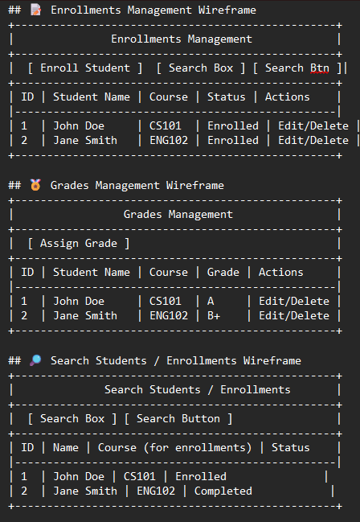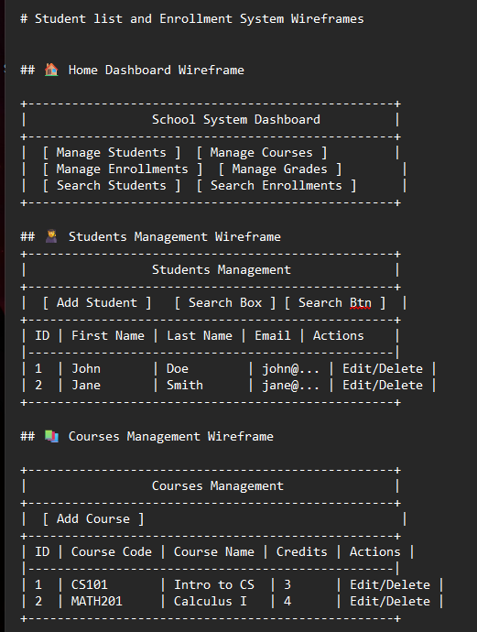

### ERDERD (Entity Relationship Diagram):

**Schema:**

**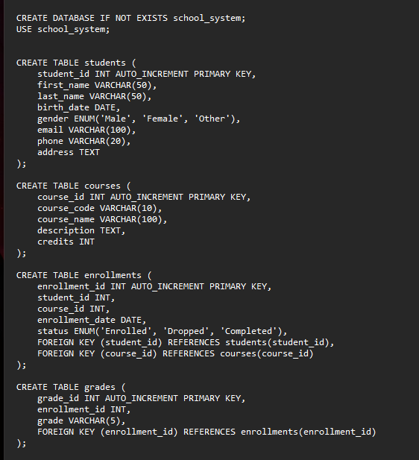**

**Screenshot of the System: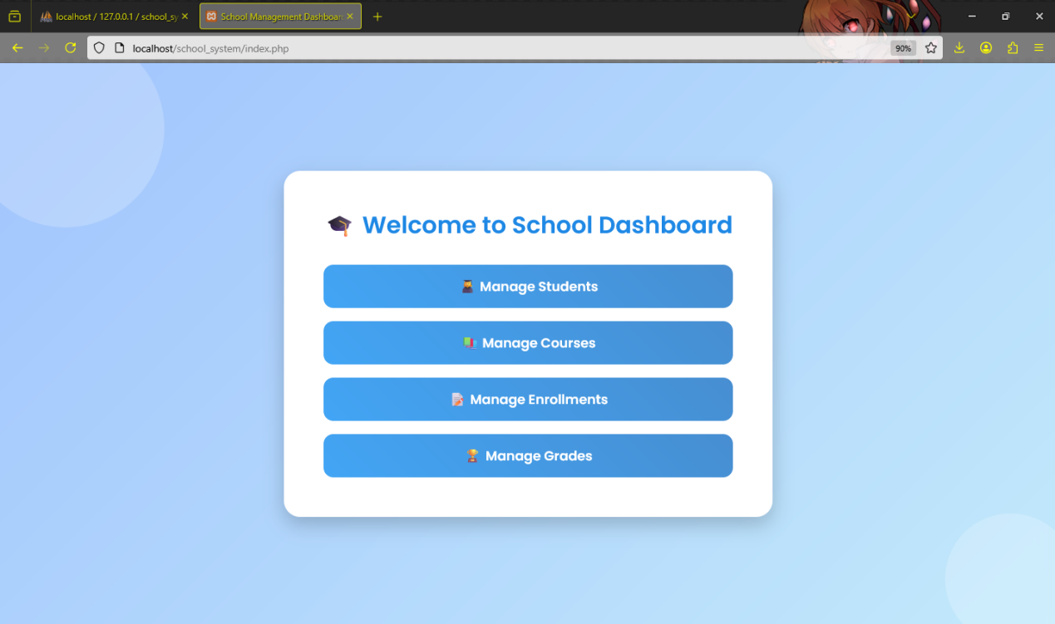**

**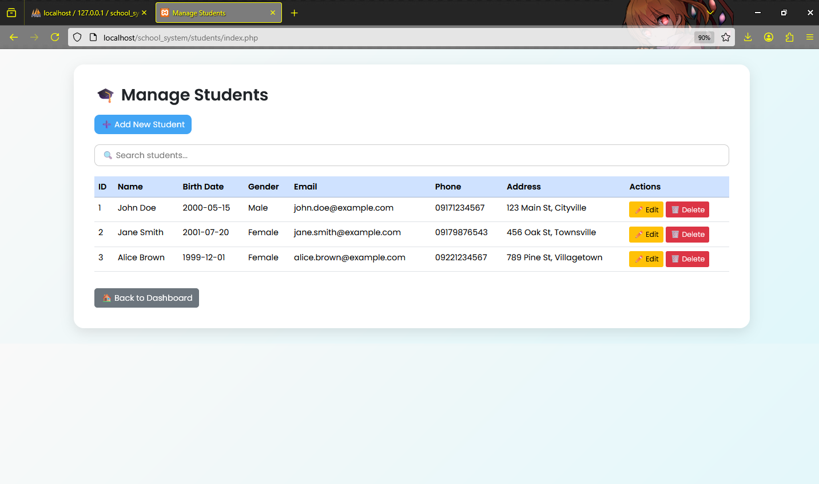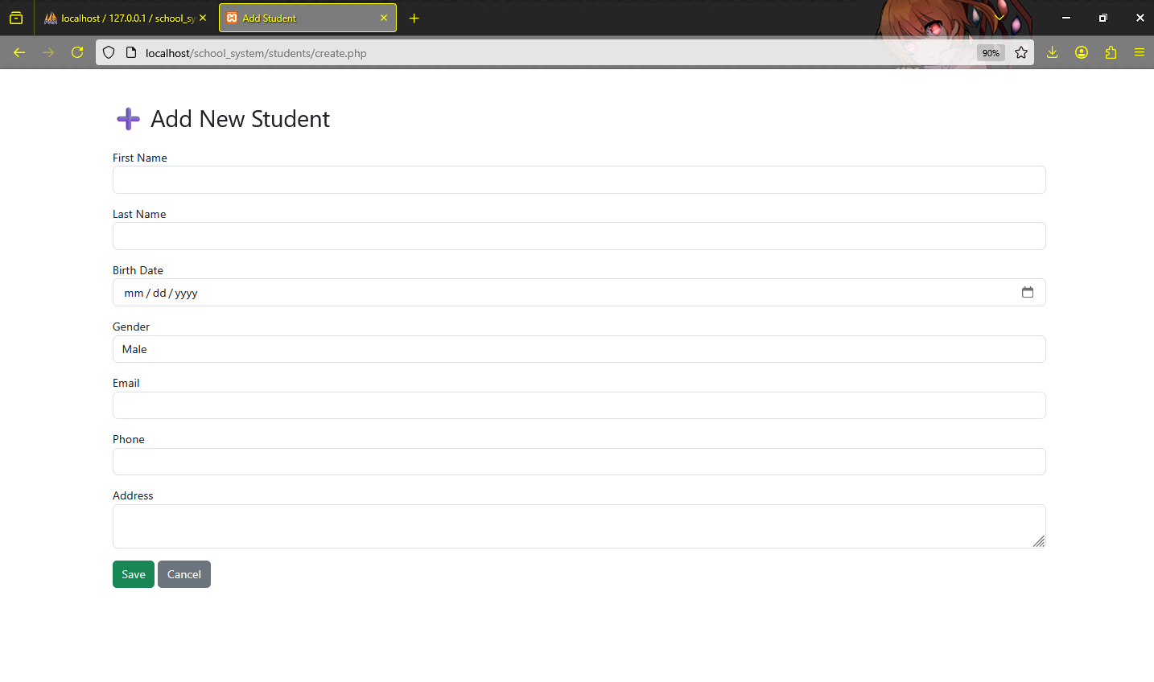**

**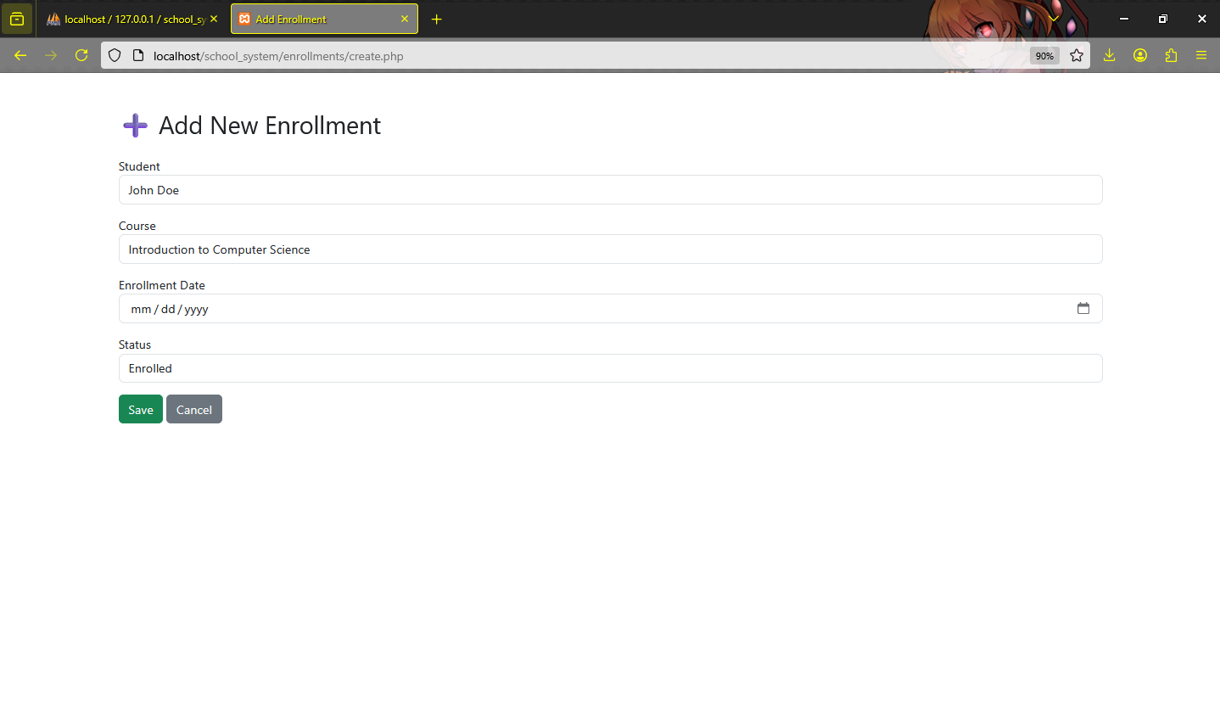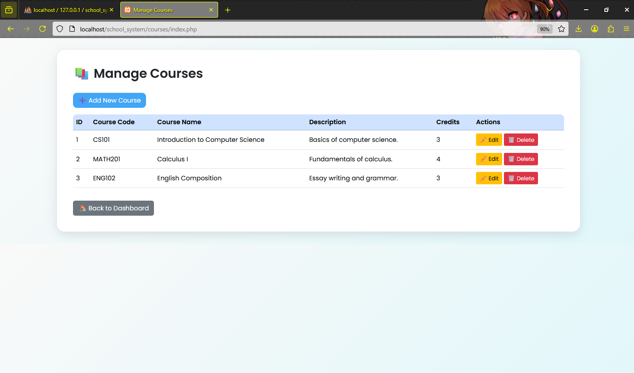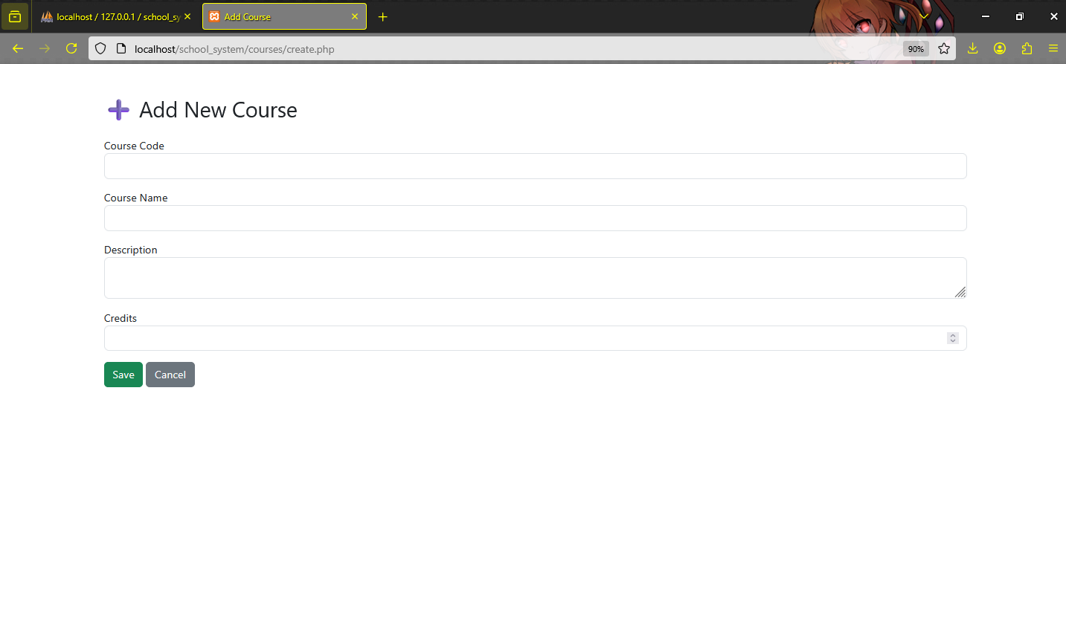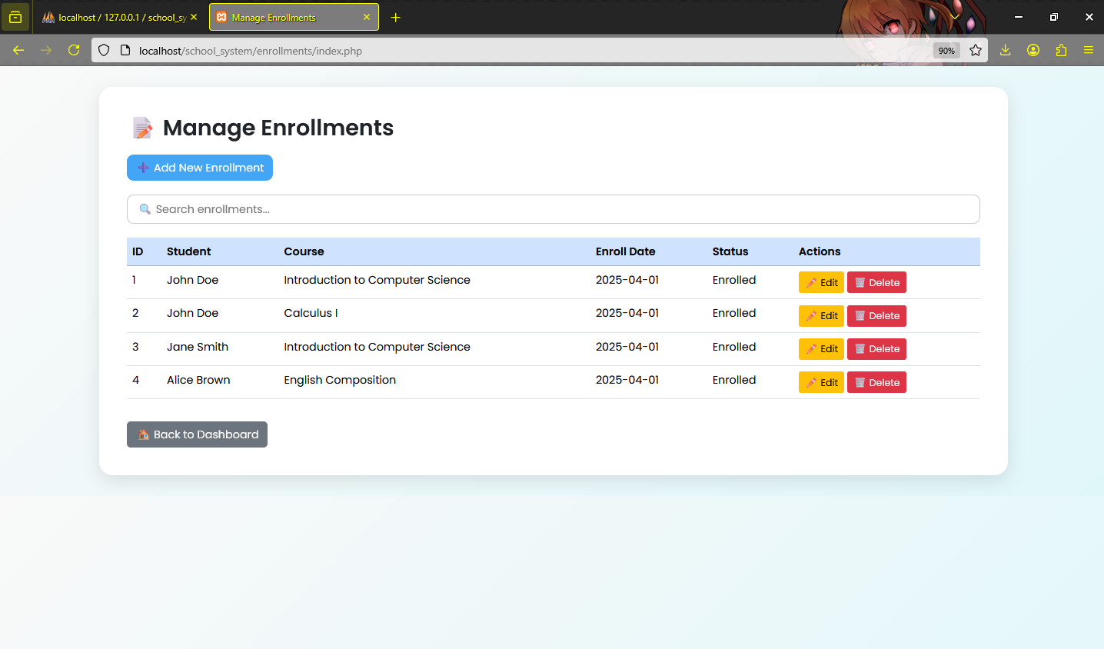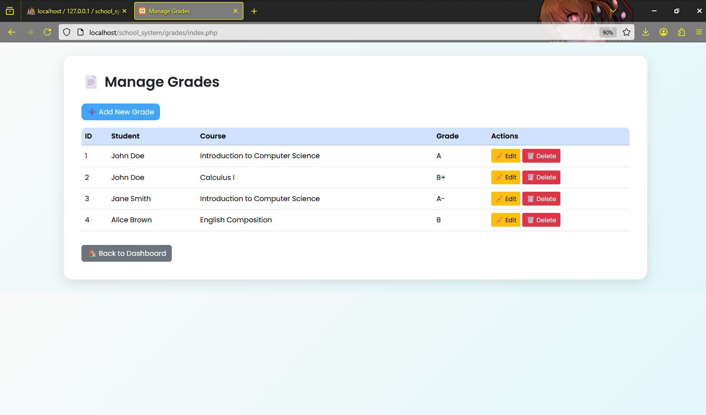**

# User Manual — School Management System

## 1. Accessing the System

Open your web browser (e.g., Chrome, Firefox, Safari).

Type the URL where the system is hosted (e.g., http://localhost/school\_system/ if local).

You will see the **Home Dashboard** with big buttons for different sections.

## 2. Setting Up the Environment

### Step 1: Install XAMPP

Download and install XAMPP: [https://www.apachefriends.org/index.html](https://www.apachefriends.org/index.html" \t "_new)

(XAMPP provides Apache server + MySQL database.)

### Step 2: Start Apache and MySQL

Open XAMPP Control Panel.

Click **Start** on:

Apache (for web server)

MySQL (for database)

(They should turn green ✅)

### Step 3: Move Your Project

Go to your XAMPP folder, then into the htdocs folder.

Example path: C:\xampp\htdocs

Create a new folder named school\_system.

Copy all your PHP project files into that folder.

### Step 4: Set Up Your Database

Open your browse

Go to [http://localhost/phpmyadmin](http://localhost/phpmyadmin" \t "_new)

Click **New**, then create a database named school\_system.

Import the SQL file:

Click the **Import** tab.

Choose your .sql file (containing students, courses, etc).

Click **Go**

### Step 5: Open Your Project

In your browser, type: [http://localhost/school\_system](http://localhost/school_system" \t "_new)

You will see your beautiful fancy dashboard!

## 3. Managing Students

Click **"Manage Students"** on the Home Dashboard.

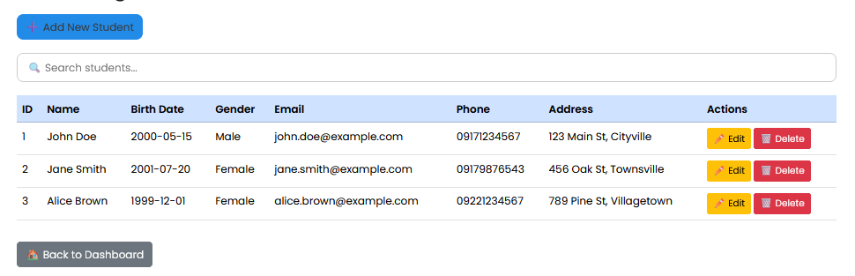View, add, edit, or delete student records easily

## 

## 4. Managing Courses

Click **"Manage Courses"**.

View, add, edit, or delete courses offered.  
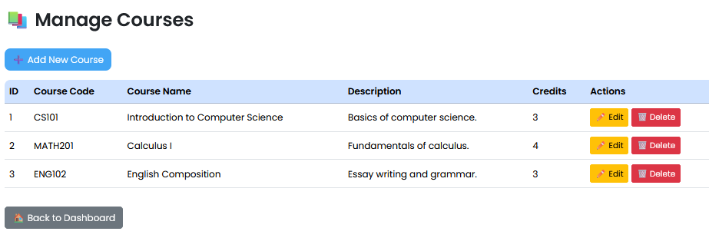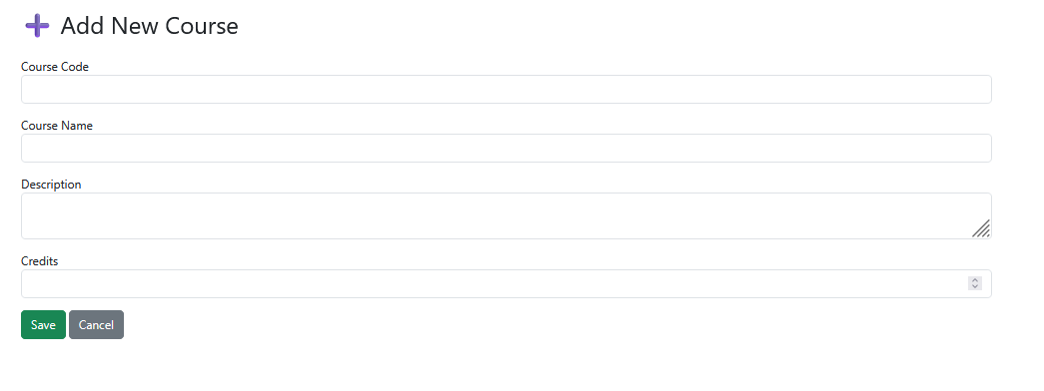

## 5. Managing Enrollments

Click **"Manage Enrollments"**.

Enroll students into courses.  
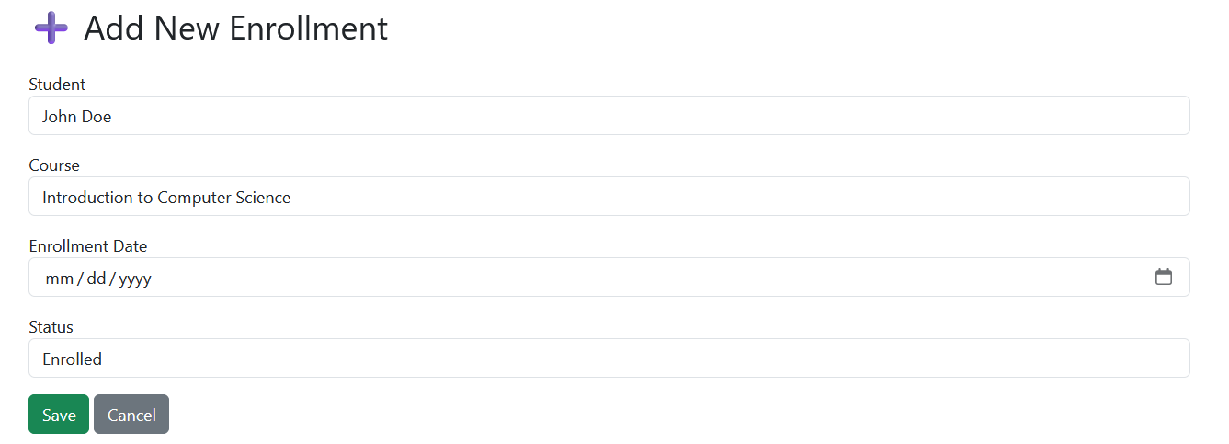

Edit or delete enrollment records if needed.  
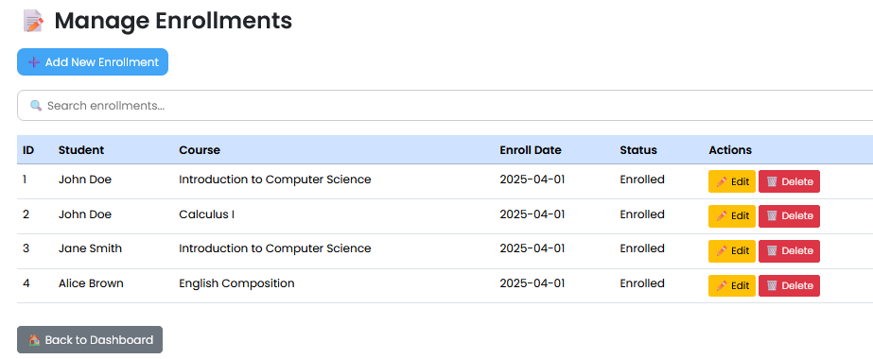

## 6. Managing Grades

Click **"Manage Grades"**.

Assign, update, or delete student grades for their courses.  
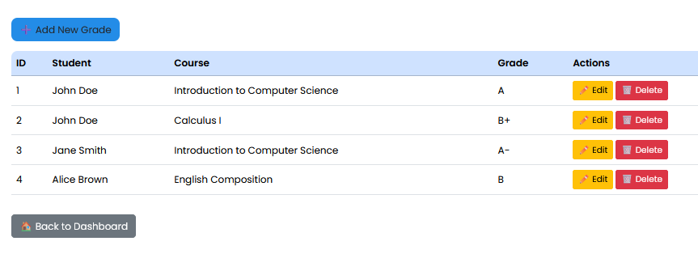  
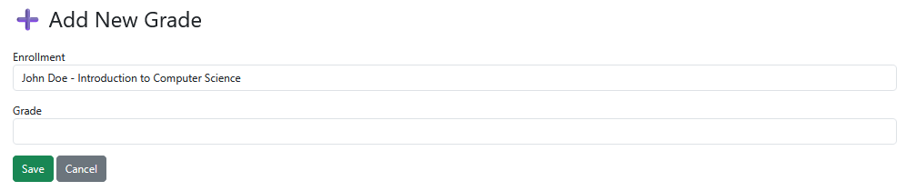

## 7. Searching Students and Enrollments

Click **"Search Students"** or **"Search Enrollments"**.

Enter keywords (student name, course) to find quick results.

## 8. Requirements to Run

- XAMPP or equivalent server environment.

- PHP installed.

- MySQL database set up.

-Web browser to access the system.